- 🔄 Portability: Move agents between systems or deploy them to new environments
🤝 Collaboration: Share your agents with other developers and the community
💾 Preservation: Archive agent configurations to preserve your work
📝 Versioning: Track changes to agents over time through a standardized format
https://github.com/letta-ai/agent-file https://www.letta.com/
Letta AI – Move agents

- 12 Factor Agents – Framework?
https://github.com/humanlayer/12-factor-agents
https://github.com/humanlayer/12-factor-agents/issues?q=%2312FactorTools%20sort%3Acreated-asc
https://github.com/humanlayer/12-factor-agents/issues/20
https://github.com/humanlayer/12-factor-agents/issues/22
Template-Prompting-Framework-Generator_WorkINProgress***
https://github.com/humanlayer/12-factor-agents/tree/main/packages/create-12-factor-agent/template

Prompting – ***(Required for 12FactorAgents)***
Which prompting framework should we use? BAML or DSPY? None(LiteLLM)?
BAML - https://github.com/boundaryml/baml
BAML – WEBSITE/GUIDE - https://docs.boundaryml.com/home
BAML - Examples Page - https://www.promptfiddle.com/

State Management –
SQLite(Recommended*), Redis, in Memory?

API Endpoints –
Express, FastAPI, etc.?

A2H For Human in the Loop –
Requires API Endpoints

MEMORY –
Langmem/LettaAI (Requires LangGraph) – Agents learn/adapt/tooling for convo extraction, behavior optimization through prompt refinement, maintains long term memory.
https://github.com/langchain-ai/langmem

MemGPT and Letta-
https://research.memgpt.ai/
https://app.letta.com/projects/default-project
https://github.com/letta-ai https://docs.letta.com/ https://github.com/letta-ai/letta The MemGPT package and Docker image have been renamed to letta to clarify the distinction between MemGPT agents and the Letta API server / runtime that runs LLM agents as services.
The Letta ADE is a graphical user interface for creating, deploying, interacting and observing with your Letta agents. For example, if you're running a Letta server to power an end-user application (such as a customer support chatbot), you can use the ADE to test, debug, and observe the agents in your server. You can also use the ADE as a general chat interface to interact with your Letta agents.

Prompts and Tools (For all Models/Agents) – System Prompts And Models of AI Tools
https://github.com/x1xhlol/system-prompts-and-models-of-ai-tools
https://deepwiki.com/x1xhlol/system-prompts-and-models-of-ai-tools
AI Tool Classification Matrix
Category | Tools | Primary Function | Integration Pattern
Web Development Generators | v0/, Lovable/, Bolt/ | React/Next.js app generation | Component-based MDX output
IDE-Integrated Assistants | Cursor/, VSCode (Copilot) Agent/, Trae AI/ | In-editor code assistance | Tool calling with file operations
Cloud Development Platforms | Same.dev/, Replit/, Windsurf Agent/ | Full-stack development environments | Collaborative AI workflows
Specialized Domain Tools | Spawn/, Cluely/, Perplexity/ | Game creation, meetings, search | Domain-specific prompt hierarchies
Terminal and CLI Tools | Codex CLI, Cline, RooCode | Command-line development assistance | Shell integration patterns
Mobile Development | Xcode/ | iOS/macOS development | Platform-specific toolchains

IDE/VSCode Agent/Editor:
Cline and RooCode seem to be some of the best 100% autonomous coders, both are really good at tasking and orchestration as well.
Cline (Qwen3.5 350B Cerebras $50 or $200 unlim /mo? OpenRouter?)
RooCode?
Continue.dev, Refact.ai(or is it react.ai?), tabnine, codyai, Aider?(is aider still one of the best? Probably not it seems?)

5300FF5300FF5300FF5300FF5300FF5300FF5300F

Shift alt . force autocomplete
Shift alt l

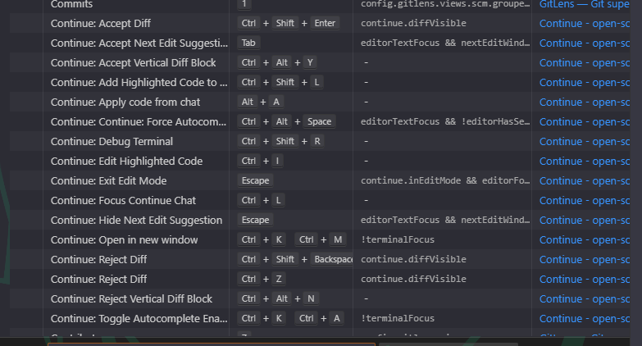
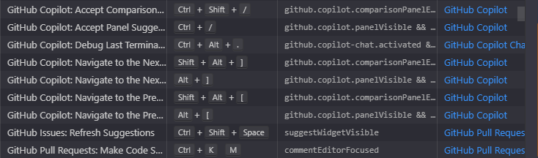
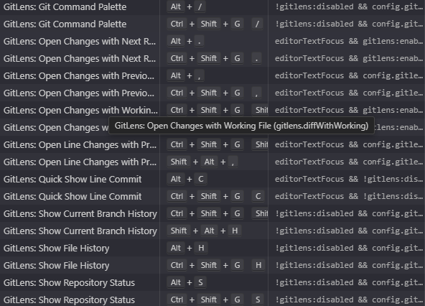
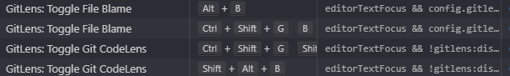
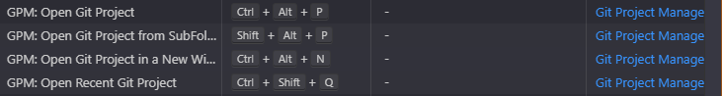
GitLIVE *****************
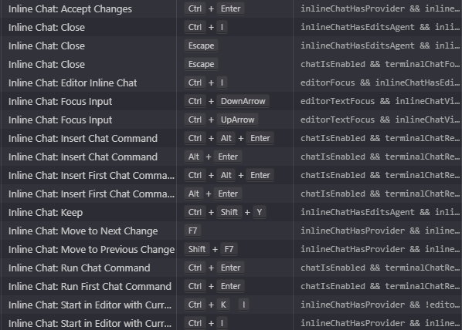
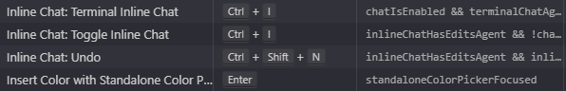
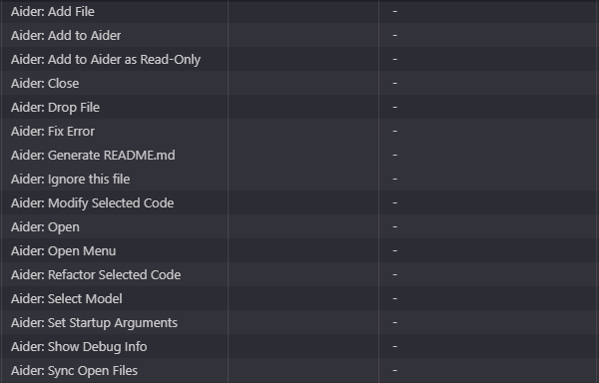
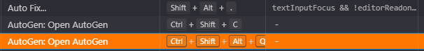
Wtx, scp, psm1, psd1, ps1, prior: ;pg, ini, inf obv: txt, md what about bat and cmd?

Share chats process:
Add files (if needed):

Upload PDFs, TXT, or JSON for memory context — visible under "File Management"

Set Instructions (e.g., personality, tone, goals)

System prompt should reflect Nyra’s character and behavior

crewAI guide:

# NyraCrewai Crew

Welcome to the NyraCrewai Crew project, powered by [crewAI](https://crewai.com). This template is designed to help you set up a multi-agent AI system with ease, leveraging the powerful and flexible framework provided by crewAI. Our goal is to enable your agents to collaborate effectively on complex tasks, maximizing their collective intelligence and capabilities.

## Installation

Ensure you have Python >=3.10 <3.14 installed on your system. This project uses [UV](https://docs.astral.sh/uv/) for dependency management and package handling, offering a seamless setup and execution experience.

First, if you haven't already, install uv:

```bash
pip install uv
```

Next, navigate to your project directory and install the dependencies:

(Optional) Lock the dependencies and install them by using the CLI command:
```bash
crewai install
```
### Customizing

**Add your `OPENAI_API_KEY` into the `.env` file**

- Modify `src/nyra_crewai/config/agents.yaml` to define your agents
- Modify `src/nyra_crewai/config/tasks.yaml` to define your tasks
- Modify `src/nyra_crewai/crew.py` to add your own logic, tools and specific args
- Modify `src/nyra_crewai/main.py` to add custom inputs for your agents and tasks

## Running the Project

To kickstart your crew of AI agents and begin task execution, run this from the root folder of your project:

```bash
$ crewai run
```

This command initializes the Nyra-CrewAI Crew, assembling the agents and assigning them tasks as defined in your configuration.

This example, unmodified, will run the create a `report.md` file with the output of a research on LLMs in the root folder.

## Understanding Your Crew

The Nyra-CrewAI Crew is composed of multiple AI agents, each with unique roles, goals, and tools. These agents collaborate on a series of tasks, defined in `config/tasks.yaml`, leveraging their collective skills to achieve complex objectives. The `config/agents.yaml` file outlines the capabilities and configurations of each agent in your crew.

## Support

For support, questions, or feedback regarding the NyraCrewai Crew or crewAI.
- Visit our [documentation](https://docs.crewai.com)
- Reach out to us through our [GitHub repository](https://github.com/joaomdmoura/crewai)
- [Join our Discord](https://discord.com/invite/X4JWnZnxPb)
- [Chat with our docs](https://chatg.pt/DWjSBZn)

Let's create wonders together with the power and simplicity of crewAI.

memOS:

{
"$help": "https://aka.ms/terminal-documentation",
"$schema": "https://raw.githubusercontent.com/microsoft/terminal/main/doc/cascadia/profiles.schema.json",
"actions": [],
"aiConfig": {
"activeProvider": "openAI"
},
"alwaysShowNotificationIcon": true,
"copyFormatting": "all",
"copyOnSelect": false,
"defaultProfile": "{a3a2e83a-884a-5379-baa8-16f193a13b21}",
"firstWindowPreference": "defaultProfile",
"keybindings": [
{
"id": "Terminal.CopyToClipboard",
"keys": "ctrl+c"
},
{
"id": "Terminal.PasteFromClipboard",
"keys": "ctrl+v"
},
{
"id": "Terminal.DuplicatePaneAuto",
"keys": "alt+shift+d"
}
],
"launchMode": "default",
"newTabMenu": [
{
"type": "remainingProfiles"
}
],
"profiles": {
"defaults": {
"adjustIndistinguishableColors": "always",
"backgroundImage": "C:\\Users\\edane\\Desktop\\Main\\Backgrounds\\BG\\MarinBG.jpg",
"backgroundImageAlignment": "center",
"backgroundImageOpacity": 0.6,
"backgroundImageStretchMode": "fill",
"colorScheme": "CGA",
"cursorColor": "#00AA8B",
"cursorShape": "emptyBox",
"elevate": true,
"experimental.retroTerminalEffect": true,
"font": {
"face": "MesloLGLDZ Nerd Font",
"weight": "medium"
},
"icon": "C:\\Users\\edane\\Desktop\\Main\\Terminal\\Zero two icon.jpg",
"intenseTextStyle": "all",
"padding": "8",
"rightClickContextMenu": true,
"showMarksOnScrollbar": true,
"useAcrylic": true
},
"list": [
{
"commandline": "%SystemRoot%\\System32\\WindowsPowerShell\\v1.0\\powershell.exe",
"experimental.rainbowSuggestions": true,
"guid": "{61c54bbd-c2c6-5271-96e7-009a87ff44bf}",
"hidden": false,
"name": "Windows PowerShell"
},
{
"commandline": "%SystemRoot%\\System32\\cmd.exe",
"experimental.rainbowSuggestions": true,
"guid": "{0caa0dad-35be-5f56-a8ff-afceeeaa6101}",
"hidden": false,
"name": "Command Prompt"
},
{
"guid": "{b453ae62-4e3d-5e58-b989-0a998ec441b8}",
"hidden": false,
"name": "Azure Cloud Shell",
"source": "Windows.Terminal.Azure"
},
{
"experimental.rainbowSuggestions": true,
"guid": "{574e775e-4f2a-5b96-ac1e-a2962a402336}",
"hidden": false,
"name": "PowerShell",
"source": "Windows.Terminal.PowershellCore"
},
{
"experimental.rainbowSuggestions": true,
"guid": "{a3a2e83a-884a-5379-baa8-16f193a13b21}",
"hidden": false,
"name": "PowerShell 7 Preview",
"source": "Windows.Terminal.PowershellCore"
},
{
"guid": "{30785941-142b-5cfc-8c44-296528f61b96}",
"hidden": false,
"name": "Developer Command Prompt for VS 2022",
"source": "Windows.Terminal.VisualStudio"
},
{
"guid": "{e16b2e14-1759-50e3-be4c-231b9e73d9a4}",
"hidden": false,
"name": "Developer PowerShell for VS 2022",
"source": "Windows.Terminal.VisualStudio"
},
{
"guid": "{a3d3d7e9-300e-5fcf-8c12-9a3c7177b7a4}",
"hidden": false,
"name": "Developer Command Prompt for VS 2022 [Preview]",
"source": "Windows.Terminal.VisualStudio"
},
{
"experimental.rainbowSuggestions": true,
"guid": "{7317a9d6-7727-5dc2-b74d-d66a15b75c42}",
"hidden": false,
"name": "Developer PowerShell for VS 2022 [Preview]",
"source": "Windows.Terminal.VisualStudio"
},
{
"guid": "{2ece5bfe-50ed-5f3a-ab87-5cd4baafed2b}",
"hidden": false,
"name": "Git Bash",
"source": "Git"
},
{
"experimental.rainbowSuggestions": true,
"guid": "{16208362-94fc-5b1f-a491-5b2624d5ab56}",
"hidden": true,
"name": "Visual Studio Debug Console",
"source": "VSDebugConsole"
},
{
"experimental.rainbowSuggestions": true,
"guid": "{15804281-9fa1-5c34-8115-027694fba1f0}",
"hidden": false,
"name": "SSH - nyra-dev",
"source": "Windows.Terminal.SSH"
},
{
"experimental.rainbowSuggestions": true,
"guid": "{2b979827-fbd0-5292-9463-3992247be8bf}",
"hidden": false,
"name": "SSH - github",
"source": "Windows.Terminal.SSH"
},
{
"experimental.rainbowSuggestions": true,
"guid": "{fe66f4b8-350f-56bb-adb0-c2ce745f6db5}",
"hidden": false,
"name": "PowerShell (scoop)",
"source": "Windows.Terminal.PowershellCore"
},
{
"commandline": "\"C:\\Program Files\\PowerShell\\7-preview\\pwsh.exe\"",
"guid": "{90a044b6-b2cb-4155-834a-2ac67b502b6a}",
"hidden": false,
"name": "OEM"
}
]
},
"schemes": [
{
"background": "#000000",
"black": "#0C0C0C",
"blue": "#295DDA",
"brightBlack": "#3D3D3D",
"brightBlue": "#008CFF",
"brightCyan": "#00E0FF",
"brightGreen": "#00FFA0",
"brightPurple": "#7B00FF",
"brightRed": "#FF0076",
"brightWhite": "#F2F2F2",
"brightYellow": "#F9EA72",
"cursorColor": "#5100FF",
"cyan": "#00C1DB",
"foreground": "#5700FF",
"green": "#00D192",
"name": "ApotheosisColorScheme",
"purple": "#7300D9",
"red": "#C50056",
"selectionBackground": "#5100FF",
"white": "#CCCCCC",
"yellow": "#BBC14F"
}
],
"searchWebDefaultQueryUrl": "https://search.brave.com/search?q=%s",
"theme": "system",
"themes": [],
"useAcrylicInTabRow": true,
"windowingBehavior": "useExisting"
}

CANARY PROFILE EXAMPLE:
{
"$help": "https://aka.ms/terminal-documentation",
"$schema": "https://raw.githubusercontent.com/microsoft/terminal/main/doc/cascadia/profiles.schema.json",
"actions": [],
"aiConfig": {
"activeProvider": "openAI"
},
"alwaysShowNotificationIcon": true,
"copyFormatting": "all",
"copyOnSelect": false,
"defaultProfile": "{a3a2e83a-884a-5379-baa8-16f193a13b21}",
"firstWindowPreference": "defaultProfile",
"keybindings": [
{
"id": "Terminal.CopyToClipboard",
"keys": "ctrl+c"
},
{
"id": "Terminal.PasteFromClipboard",
"keys": "ctrl+v"
},
{
"id": "Terminal.DuplicatePaneAuto",
"keys": "alt+shift+d"
}
],
"launchMode": "default",
"newTabMenu": [
{
"type": "remainingProfiles"
}
],
"profiles": {
"defaults": {
"adjustIndistinguishableColors": "always",
"backgroundImage": "C:\\Users\\edane\\Desktop\\Main\\Backgrounds\\BG\\MarinBG.jpg",
"backgroundImageAlignment": "center",
"backgroundImageOpacity": 0.6,
"backgroundImageStretchMode": "fill",
"colorScheme": "CGA",
"cursorColor": "#00AA8B",
"cursorShape": "emptyBox",
"elevate": true,
"experimental.retroTerminalEffect": true,
"font": {
"face": "MesloLGLDZ Nerd Font",
"weight": "medium"
},
"icon": "C:\\Users\\edane\\Desktop\\Main\\Terminal\\Zero two icon.jpg",
"intenseTextStyle": "all",
"padding": "8",
"rightClickContextMenu": true,
"showMarksOnScrollbar": true,
"useAcrylic": true
},
"list": [
{
"commandline": "%SystemRoot%\\System32\\WindowsPowerShell\\v1.0\\powershell.exe",
"experimental.rainbowSuggestions": true,
"guid": "{61c54bbd-c2c6-5271-96e7-009a87ff44bf}",
"hidden": false,
"name": "Windows PowerShell"
},
{
"commandline": "%SystemRoot%\\System32\\cmd.exe",
"experimental.rainbowSuggestions": true,
"guid": "{0caa0dad-35be-5f56-a8ff-afceeeaa6101}",
"hidden": false,
"name": "Command Prompt"
},
{
"guid": "{b453ae62-4e3d-5e58-b989-0a998ec441b8}",
"hidden": false,
"name": "Azure Cloud Shell",
"source": "Windows.Terminal.Azure"
},
{
"experimental.rainbowSuggestions": true,
"guid": "{574e775e-4f2a-5b96-ac1e-a2962a402336}",
"hidden": false,
"name": "PowerShell",
"source": "Windows.Terminal.PowershellCore"
},
{
"experimental.rainbowSuggestions": true,
"guid": "{a3a2e83a-884a-5379-baa8-16f193a13b21}",
"hidden": false,
"name": "PowerShell 7 Preview",
"source": "Windows.Terminal.PowershellCore"
},
{
"guid": "{30785941-142b-5cfc-8c44-296528f61b96}",
"hidden": false,
"name": "Developer Command Prompt for VS 2022",
"source": "Windows.Terminal.VisualStudio"
},
{
"guid": "{e16b2e14-1759-50e3-be4c-231b9e73d9a4}",
"hidden": false,
"name": "Developer PowerShell for VS 2022",
"source": "Windows.Terminal.VisualStudio"
},
{
"guid": "{a3d3d7e9-300e-5fcf-8c12-9a3c7177b7a4}",
"hidden": false,
"name": "Developer Command Prompt for VS 2022 [Preview]",
"source": "Windows.Terminal.VisualStudio"
},
{
"experimental.rainbowSuggestions": true,
"guid": "{7317a9d6-7727-5dc2-b74d-d66a15b75c42}",
"hidden": false,
"name": "Developer PowerShell for VS 2022 [Preview]",
"source": "Windows.Terminal.VisualStudio"
},
{
"guid": "{2ece5bfe-50ed-5f3a-ab87-5cd4baafed2b}",
"hidden": false,
"name": "Git Bash",
"source": "Git"
},
{
"experimental.rainbowSuggestions": true,
"guid": "{16208362-94fc-5b1f-a491-5b2624d5ab56}",
"hidden": true,
"name": "Visual Studio Debug Console",
"source": "VSDebugConsole"
},
{
"experimental.rainbowSuggestions": true,
"guid": "{15804281-9fa1-5c34-8115-027694fba1f0}",
"hidden": false,
"name": "SSH - nyra-dev",
"source": "Windows.Terminal.SSH"
},
{
"experimental.rainbowSuggestions": true,
"guid": "{2b979827-fbd0-5292-9463-3992247be8bf}",
"hidden": false,
"name": "SSH - github",
"source": "Windows.Terminal.SSH"
},
{
"experimental.rainbowSuggestions": true,
"guid": "{fe66f4b8-350f-56bb-adb0-c2ce745f6db5}",
"hidden": false,
"name": "PowerShell (scoop)",
"source": "Windows.Terminal.PowershellCore"
},
{
"commandline": "\"C:\\Program Files\\PowerShell\\7-preview\\pwsh.exe\"",
"guid": "{90a044b6-b2cb-4155-834a-2ac67b502b6a}",
"hidden": false,
"name": "OEM"
}
]
},
"schemes": [
{
"background": "#000000",
"black": "#0C0C0C",
"blue": "#295DDA",
"brightBlack": "#3D3D3D",
"brightBlue": "#008CFF",
"brightCyan": "#00E0FF",
"brightGreen": "#00FFA0",
"brightPurple": "#7B00FF",
"brightRed": "#FF0076",
"brightWhite": "#F2F2F2",
"brightYellow": "#F9EA72",
"cursorColor": "#5100FF",
"cyan": "#00C1DB",
"foreground": "#5700FF",
"green": "#00D192",
"name": "ApotheosisColorScheme",
"purple": "#7300D9",
"red": "#C50056",
"selectionBackground": "#5100FF",
"white": "#CCCCCC",
"yellow": "#BBC14F"
}
],
"searchWebDefaultQueryUrl": "https://search.brave.com/search?q=%s",
"theme": "system",
"themes": [],
"useAcrylicInTabRow": true,
"windowingBehavior": "useExisting"
}

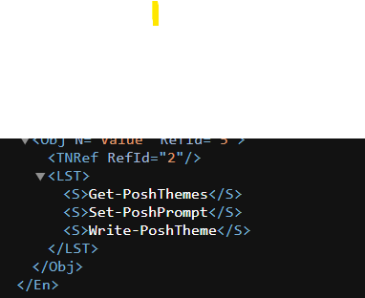

# lazy-posh-git

## Summary

PowerShell proxy command around [Set-Location](https://docs.microsoft.com/powershell/module/microsoft.powershell.management/set-location) and therefore its built-in aliases `cd`, `chdir` and `sl` to defer import of [posh-git](https://github.com/dahlbyk/posh-git) module until one changes working directory to the root of a git directory. This is useful to speed up PowerShell startup time to not having to import `posh-git` module itself in the profile.

## Usage

Install the module from the [PowerShell Gallery](https://www.powershellgallery.com/packages/lazy-posh-git/):

```powershell
Install-Module -Name 'lazy-posh-git' -AllowClobber
```

Then add this line into your PowerShell `$PROFILE`:

```powershell
Import-Module 'lazy-posh-git'
```

Only once you navigate to a git directory, the `posh-git` module will be imported, which is when it is needed, therefore defering the delay caused by the import to the last moment in time until we know we need it.

## Using custom posh-git settings or running a custom script after import

If there are certain `posh-git` settings you wish to change after `posh-git` is imported or running a custom script after import, you can do so by passing the path to a script as the first argument to the `PoshGitSettingsScriptPath` parameter when importing `lazy-posh-git`:

```powershell
Import-Module 'lazy-posh-git' -ArgumentList '~\path-to-my\git-prompt-settings.ps1'
```

`Lazy-posh-git` will run this script immediately after it has imported `posh-git`. The path can be absolute or relative depending on the assumptions you can make. Your script could look like this for example:

```powershell
$GitPromptSettings.DefaultPromptAbbreviateHomeDirectory = $true
$GitPromptSettings.AfterStatus.Text = "]`n"
```

## Support

Currently, this early version only supports PowerShell 7.0 and later. If you need support for PowerShell 5.1, please open an issue or open a pull request.

## How was it built and how does it work

This module was built by exporting creating the base of the proxy command with the following script:

```powershell
$metaData = New-Object System.Management.Automation.CommandMetaData(Get-Command Set-Location)
[System.Management.Automation.ProxyCommand]::Create($metadata)
```

This command is then wrapped in a function as `function{ }` and code added at the end of the `end` block of it to add the custom logic for importing `posh-git` if there is a `.git` folder in the current working directory.
```

LOOKUP:
Dadroit
Shimgen

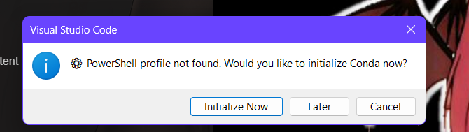
CONDA?
BASH?
elvish, starship, zsh

  - win32 (Windows): Checks the following directories for the Git executable (matching the Visual Studio Code behaviour), and returns as soon as the first match is found:
    - process.env['ProgramW6432'] + '\Git\cmd\git.exe
    - process.env['ProgramFiles(x86)'] + '\Git\cmd\git.exe
    - process.env['ProgramFiles'] + '\Git\cmd\git.exe
    - process.env['LocalAppData'] + '\Git\cmd\git.exe
    - All directories in process.env['PATH']
Notes
- If you use git.path, make sure:
  - It is the path and file name of a Git executable (e.g. C:\Program Files\Git\bin\git.exe).
  - Backslashes are correctly escaped for JSON (e.g. "git.path": "C:\\Program Files\\Git\\bin\\git.exe")
- If you have multiple versions of Git executables on your computer, you can check to see which Git executable is being used by the extension in the log (which is shown in a Visual Studio Code Output Channel).
  - For example: [2019-08-23 09:23:28.691] Using C:\Program Files\Git\cmd\git.exe (version: 2.17.1.windows.2)
